Software Design Description

Videogram

1.0.0

February 7, 2020

Computer Science Department, Biola University

|  |  |  |  |
| --- | --- | --- | --- |
| Version | Primary Author(s) | Desc. Of Version | Date Completed |
| 1.0 | Derek James | Initial Version | 2/7/2020 |
|  |  |  |  |
|  |  |  |  |
|  |  |  |  |

**1 INTRODUCTION 4**

**1.1 Document Conventions 4**

**1.2 Design Overview 4**

**1.3 Requirements Traceability Matrix 4**

**2 SPECIFIC ARCHITECTURAL DESIGN 7**

2.1 Chosen System Architecture 7

2.2 System Interface Description 7

**3 DETAILED DESCRIPTION OF COMPONENTS 8**

3.1 Database Component 8

3.2 Back-End Application Component 8

3.3 User Interface Component 9

**4 USER INTERFACE DESIGN 10**

4.1 Description of the User Interface 10

4.1.1 Screen Images 10

4.1.2 Objects and Actions 10

**5 ADDITIONAL MATERIAL 10**

**1 INTRODUCTION**

**1.1 Document Conventions**

|  |  |
| --- | --- |
| **AWS** | Amazon Web Services |

**1.2 Design Overview**

This system design document gives an overview of the complete system architecture along with its internal components and interfaces.

**1.3 Requirements Traceability Matrix**

|  |  |  |  |  |
| --- | --- | --- | --- | --- |
| **Req Type** | **Req ID.** | **Description** | **Component** | **Test** |
| External Interface Requirement | 21100 | User interface shall run on any mobile device supported by AndroidOS, Windows Phone, or iOS. Not compatible with non-mobile devices (with the exception of emulators). | User Interface | Verify with test subject evaluations. |
| 21101 | The user interface shall be user friendly, simplistic, familiar, and pleasing to look at. | User Interface | Verify with test subject evaluations. |
| 21102 | The user interface shall comply with mobile UI accessibility standards. (WCAG) | User Interface | Verify with test subject evaluations. |
| 21300 | The database shall utilize AWS for database hosting. | Database | In Progress |
| 21301 | The database shall interface with the back-end application by transmitting data in JSON format. | Database | In Progress |
| 21302 | The back-end application shall interface with the front-end UI. | Application | Verify that a Rest API is available to the user interface. |
| 21400 | The back-end application shall utilize the Hypertext Transfer Protocol (HTTP) to interface with the database. | Application | In Progress |
| 21401 | The back-end application shall send HTTP GET requests to the appropriate AWS url to query data from the database. | Application | In Progress |
| 21402 | The back-end application shall send HTTP POST requests to the appropriate AWS url to insert data into the database. | Application | In Progress |
| Functional Requirement | 22200 | The software shall require a user account for any operation. | Application | Verify an attempt to log in without any credentials results in failure. |
| 22201 | The software shall require user authentication upon startup. | Application | Verify an attempt to log in without any credentials results in failure. |
| 22202 | The software shall provide an option allowing a user to find other users. | Application | Verify a search feature is present. |
| 22203 | The software shall provide an option allowing a user to share a video. | Application | Verify a upload video feature is present. |
| 22204 | The software shall store any video that is uploaded by a user. | Application | Verify an uploaded video is saved for viewing. |
| 22205 | The software shall present any videos of any specified user. | Application | Verify a user can see any videos that they have uploaded.. |
| Reliability Requirement | 23100 | Extremely minimal application crashing. | Application | Verify with test subject evaluations. |
| 23101 | Minimal latency between backend and front-end. | Database | Verify with test subject evaluations. |
| Availability Requirement | 23200 | The software shall be available for mobile devices only. | User Interface |  |
| Security Requirement | 23300 | The software shall ONLY collect the following personal data:  - Username  - Password  - Email  - Full Name  - Biography | Database | Verify that the user interface implementation does not ask for any other personal data. |
| 23301 | The software shall not use any personal data collected for a user outside of the scope of the application. | Database | In Progress |
| 23302 | The software shall not share any personal data collected for a user with any 3rd party systems. | Database | In Progress |
| 23303 | The software shall erase any personal data collected for a user upon account deletion. | Database | In Progress |
| 23304 | The software shall not use any uploaded photos/videos for a user outside of the scope of the application. | Database | In Progress |
| 23305 | The software shall not use any uploaded photos/videos for a user with any 3rd party systems. | Database | In Progress |
| 23306 | The software shall erase any uploaded photos/videos for a user upon account deletion. | Database | Verify by utilizing the back-end application Rest API to verify that user uploads are erased. |
| Portability Requirement | 23500 | The software shall run on AndroidOS, Windows and iOS systems. | User Interface | In Progress |
| Performance Requirement | 23600 | The database shall respond to any necessary UI requests within 5 seconds or less. | Database | Verify with test subject evaluations. |
| 23601 | The front-end UI shall parse and apply backend responses within 5 seconds or less. | User Interface | Verify with test subject evaluations. |
| 23602 | Video Streaming quality standards shall include:  - 30 Frames Per Second  - 1080px720p HD  - 256kbps audio stream | User Interface | In Progress |
| Safety Requirement | 23700 | The database shall not be deleted or destroyed, only changed in form. | Database | In Progress |
| Database Requirement | 24000 | The database shall be set up so that no anomalies exist. | Database | In Progress |
| 24001 | The database shall store the following user personal data:  - Username  - Password  - Biography  - Email  - Full Name | Database | Verify by utilizing the back-end application Rest API to verify that only the following data is available. |
| 24002 | The database shall store links to the following user media data:  - Profile picture  - Uploaded Videos | Database | Verify the retrieval of media links with the back-end application Rest API. |
| 24003 | The database may store the following user uploaded video data:  - Description  - Location  - Date  - Tags  - Length  - Quality  - Likes  - Comments | Database | Verify by utilizing the back-end application Rest API to verify that only the following data is available. |

**2 SPECIFIC ARCHITECTURAL DESIGN**

2.1 Chosen System Architecture

The complete functionality of the system includes a 3 tier architecture. The three components that make up the system include:

* Database
* Back-end application
* User interface

The back endpoint (database) and front endpoint (user interface) collaborate via the back-end application.

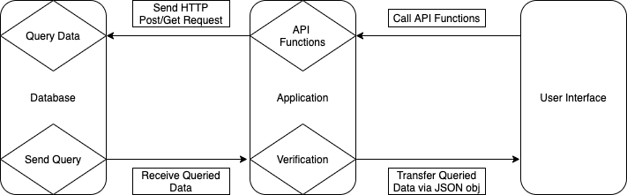

2.2 System Interface Description

The back end application will use http protocols to implement a RESTful api and pass JSON objects for communication between the database and the user interface. We will be using the MySQL driver for node.js to interface between the backend application and the database.

**3 DETAILED DESCRIPTION OF COMPONENTS**

3.1 Database Component

The database will be constructed to the following EER diagram. Additional tables may be needed in the case of new features.

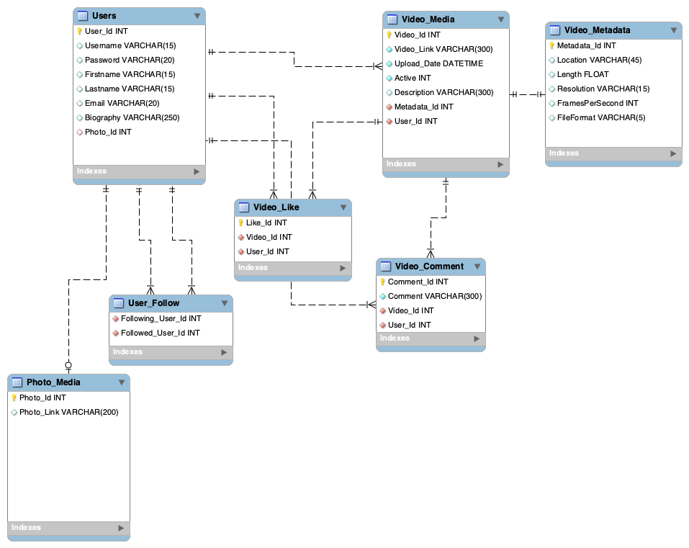

3.2 Back-End Application Component

API:

Functions:

UserCreation (username, firstname, lastname, password, email)

Output: Success or not.

Login(username, password):

Output: Success or not.

Logout(username):

Output: Success or not.

DeleteUser(username, password):

Output: Success or not.

FindUsers(username):

Output: user profile pics with username of users with the character

sequence.

UploadVideo(username, video):

Output: success or not.

DownloadFeed(username):

Output: user’s feed.

LikeVideo(username that liked the video, videoID):

Output: Success or not.

CommentOnVideo(comment, username of user commenting, videoID):

Output: Success or not.

DownloadVideoComments(videoID):

Output: comments of the video.

SendMessage(username of sender, message, username of receiver):

Output: Success or not.

DeleteMessage(username, messageID):

Output: Success or not.

Delete Messages(username, {messageIDs}):

Output: Success or not.

3.3 User Interface Component

**4 USER INTERFACE DESIGN**

4.1 Description of the User Interface

The user interface utilizes a very easy to use, familiar design that is easy on the eyes. Primarily, the design is themed “Retro” with contrasting colors and horizontal scrolling.

4.1.1 Screen Images

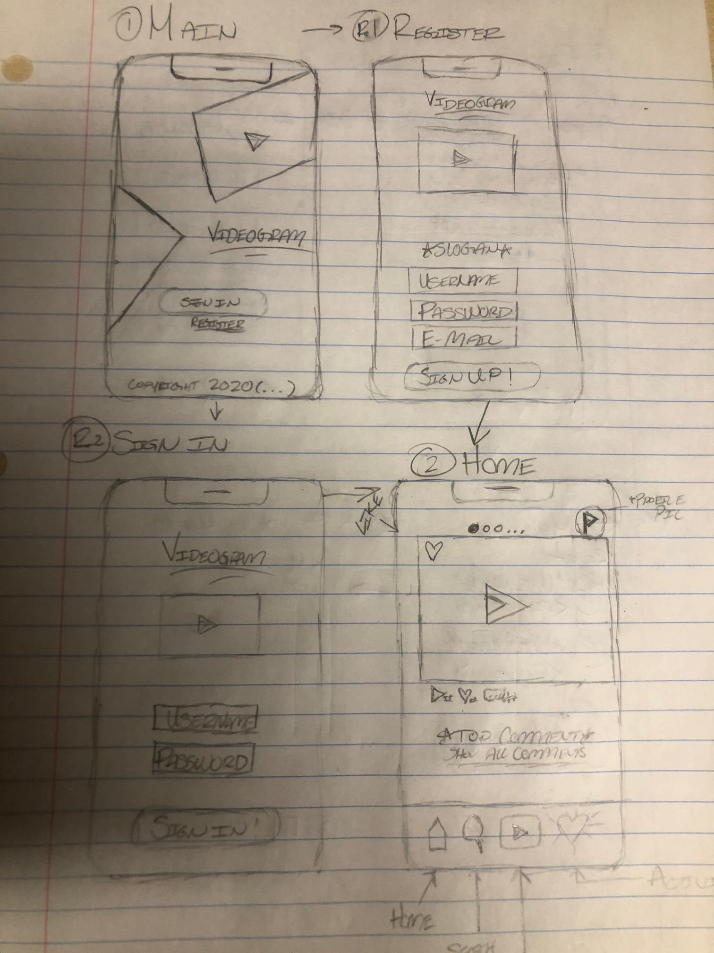

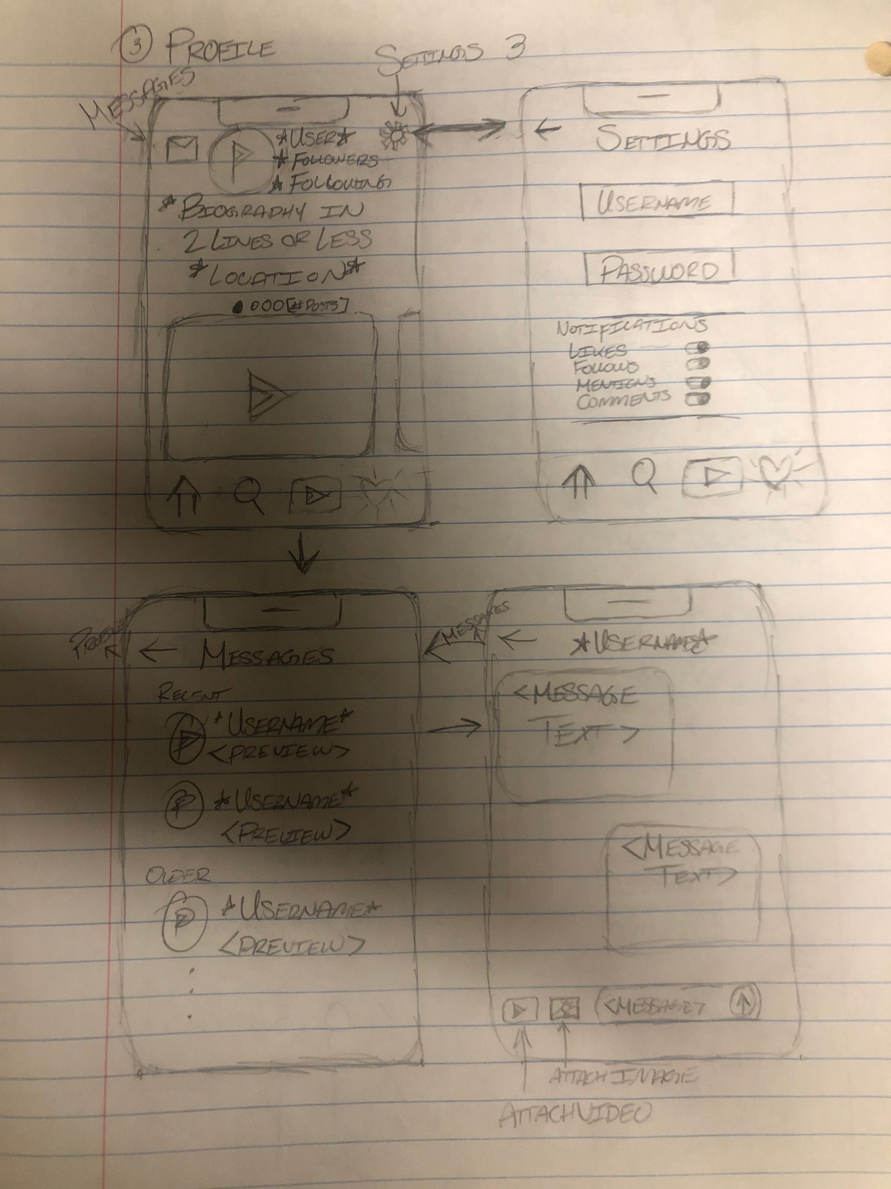

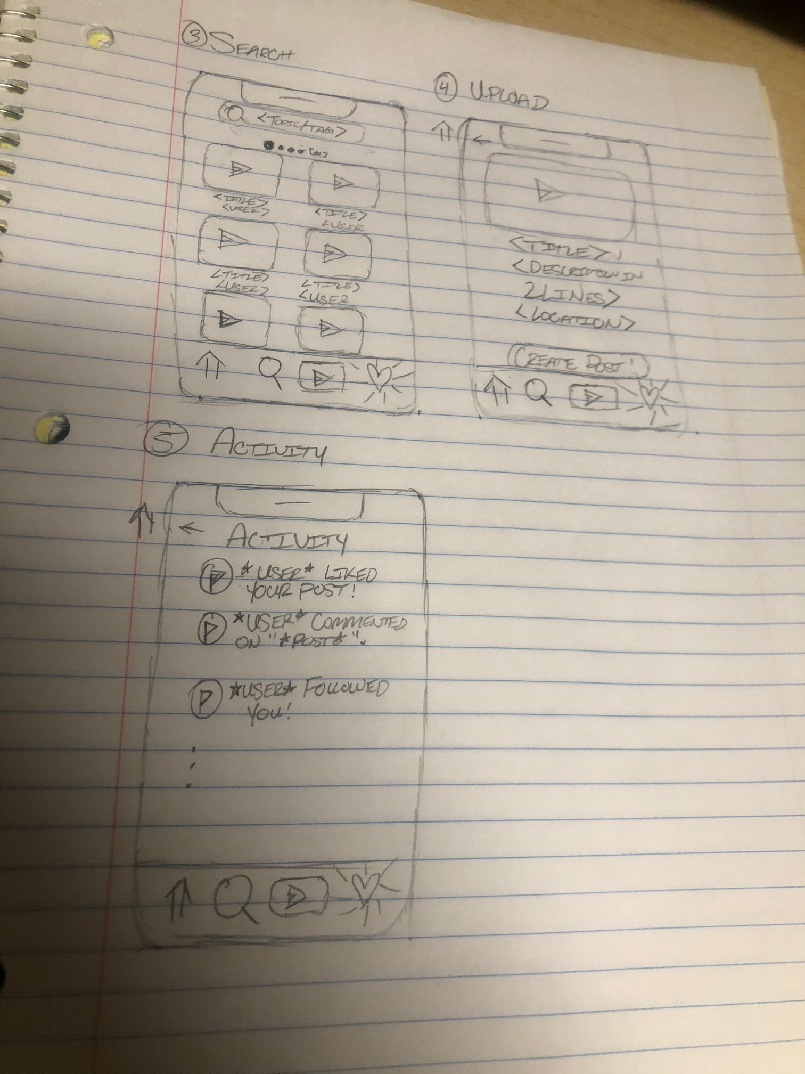

**5 ADDITIONAL MATERIAL**